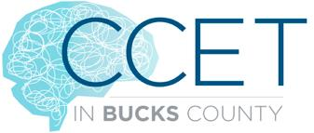
Directions to the Bensalem High School Online CCET Concussion Training Module:
- Click on link: https://forms.gle/1W1U4hEcBz43t68m6
to open the online learning module for Concussion Education.
- Fill out your FIRST and LAST name, GRADE, SPORT, and EMAIL. Then click on then go to the next section.
- The next section is the Pre-Test it is a total of 10 questions. Complete this pretest and then go to the next section.
- The next section is the PRESENTATION. There are 3 total modules. After each module you will answer a few questions about that module. There is a total of 10 questions.
- Each section of this presentation takes approximately 10 minutes.
- When the presentation for each section is completed you will need to answer the MULTIPLE CHOICE OR TRUE/FALSE questions in each section.
- When you have completed the presentation and all the questions you will have completed the education portion for school.
- Your Athletic Trainer will be able to see who has completed this presentation and the score you receive on the questions.
- This will fulfill Part 1 of 2 of your mandatory Concussion Education for the 2021-2022 school year. Communicate with your Athletic Director, Athletic Trainer and/or Coaches on how the ImPACT Test will be completed for student athletes in your school.

